Soraya Marcano

List of recent work:

- 2011. Fabric pieces. Fabric, hair, thread, acrylic paint. (3 objects)
- 2011. Soft Materials. Light Works. Paper boats, silk bag, thread, silk hand.
- 2011. Soft Materials. Light Works. Tea Bags, gauze, thread. 12” x 9”
- 2011. Soft Materials. Light Works. Gauze, thread. 11” X 8”
- 2011. Soft Materials. Light Works. White crochet scarf. 44" X 5." 2011.
- 2011. Soft Materials. Light Works. White stones, brass wire.
- 2012. Soft Materials. Light Works. Paper boats, hand. Photograph.
- 2012. Soft Materials. Light Works. Paper boat, water. Photograph.
- 2012 Lingerie. Video. 1:10 minutes.

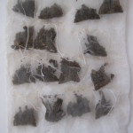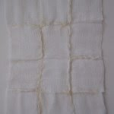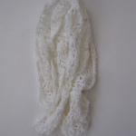
3 4 5

